Advanced Software Engineering

Lab – 4

WEB SERVICE – Travel Guide

Step 1: Mobile Application gives advice for trip planning which gives the information about the distance between two specified locations and the time associated with the travel.

Figure 1&2 shows the distance between Hyderabad and Mumbai and also the associated

with it.

Figure 3 shows the distance and time between Kansas city and sandiego.

Figure 4 shows the distance between newyork and Chicago.

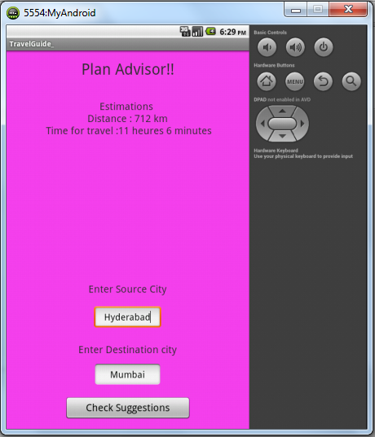

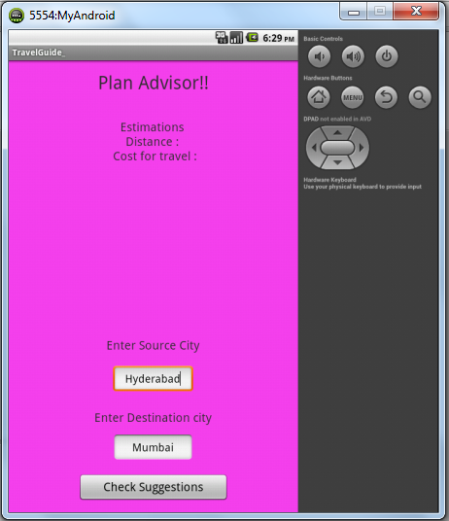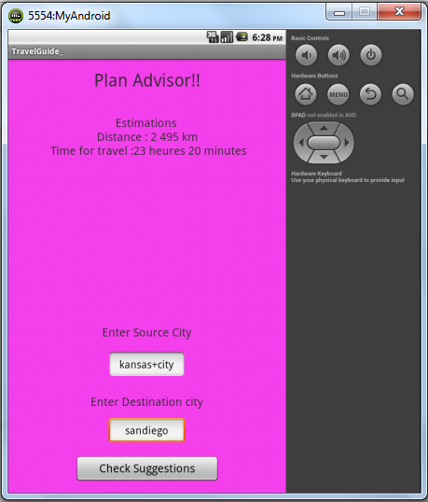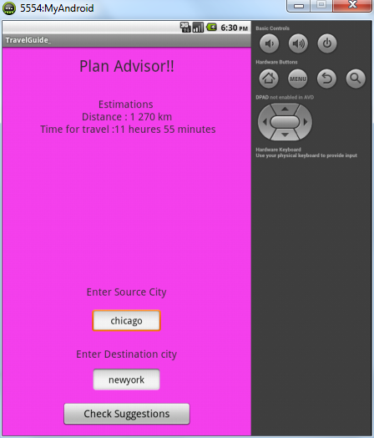

II creating tables, inserting and deleting data into database and deployed the soap web services into IIS web server.

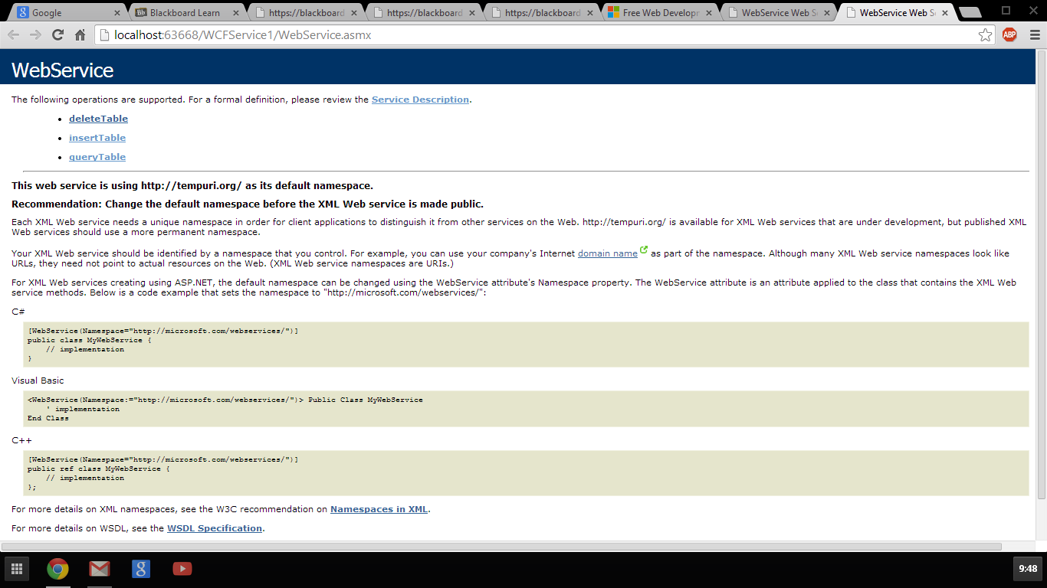

Step 1: Inserting values into table.

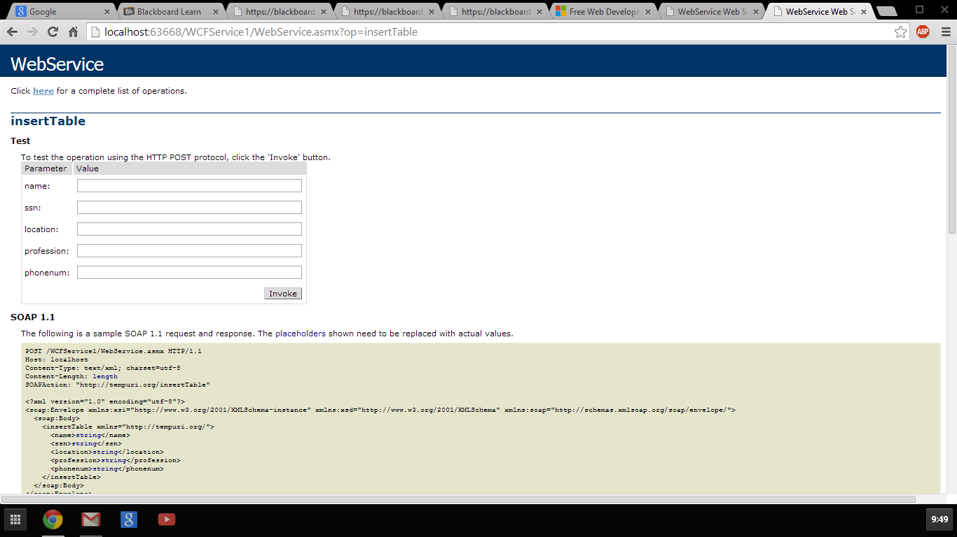

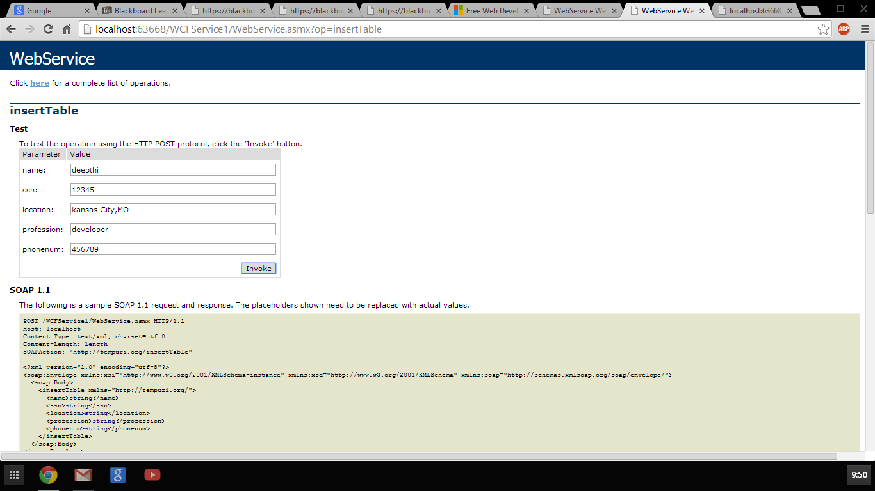

Step 2 : quering the table content using name.

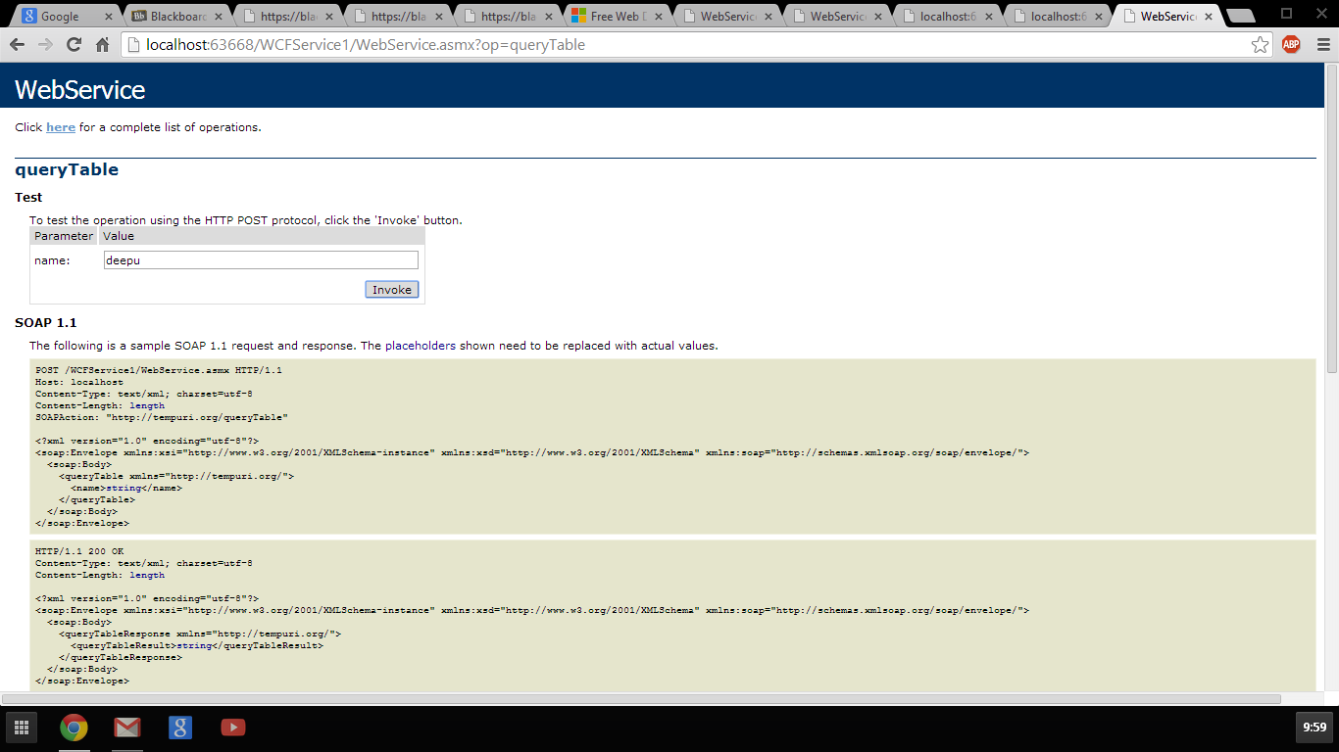

Step 3: Deleting the Table Content by giving the values that are already existed.

